Sports Promo Poster
- Select an athlete to use for the poster from the folder. Zoom in to 200% minimum and use the pen tool to make a path around the athlete. Remember to holt Alt when clicking on the anchor point to remove the handle bar (like you are used to doing in Illustrator). Turn the path into a selection by clicking on selection in the control panel.
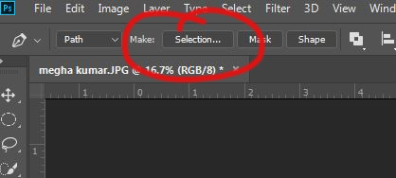
- Add a layer mask in the layers panel to mask out the background. Remove any additional areas as needed, such as shoe lace loops or under the athlete’s arm by making another path with the pen, turning it into a selection, and painting inside the selection with a black paint brush.
- Next, use the eye dropper tool (press I on the keyboard) and choose a color from the uniform—either purple or gold/yellow.
- When you have a color you like, create a new layer and drag this layer to the bottom. Fill the layer with the purple or gold by going to Edit>Fill>Contents>Foreground color.
- Make another new layer. It should be above your purple or gold background but below your athlete. Fill this layer with 50% gray in Edit>Fill.
- On this gray layer, go to Filter>Render>Fibers. Use a variance of 7, a strength of 37, and click randomize until you like it. It will change each time you click randomize. Click OK. Then, change the blend mode to soft light (where it says “Normal” in the layers panel) and drop the layer opacity to 60%.
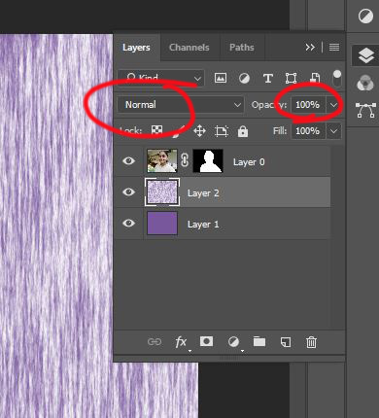
- Next, click on your athlete layer and press Control + J to make a duplicate of the layer. Click back on the original athlete layer and press Control + T. Enlarge the athlete so that you can only see him or her from the waste up. Be sure to hold SHIFT while you enlarge and drag from a CORNER. Drop the layer opacity down to 50%.
- Now click on the athlete copy layer, the top one. Double click on the layer over the right side (don’t click on the name of the layer or it will think you just want to rename it).

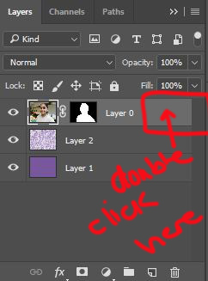

This will bring up the Layer Styles. Then click on the words Outer Glow. For mode, use Screen, 75% opacity, and white for the color, and for Technique use softer and a size of 16. Leave other settings alone. Click OK.
- Still on the athlete copy layer, the top one, Control click (hold down Control while clicking) on the layer mask to select the athlete again.
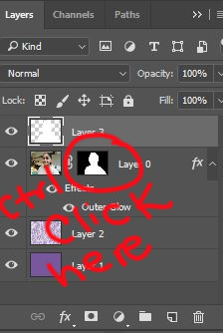
- Make a new layer on top of all other layers. Fill the selection with white in Edit>Fill. It will cover your athlete for now. Deselect (Control + D).
- Go to Filter>Stylize>Wind. You will need to decide which way to make the wind go. If you athlete is moving toward or facing the left, you’ll want the wind to come from the left. If your athlete is facing/moving right, you’ll want from the right. To make the wind more visible, press Control + Alt+ F to add wind. Do so several times (maybe three or four) until you can really see the wind.
- Now Control click on the athlete layer mask thumbnail again (as in the picture above), but make sure you still have the top, white-filled layer active. Then press Backspace so you can see your athlete again.
- Now for the finishing touches. Select the text tool (T) and use the font Impact. Press Caps lock and then type PRIDE & TRADITION in white. Add a drop shadow by double clicking on the TEXT layer like you did in step 8 (see picture) and choose drop shadow. Leave the settings alone, except change the distance, spread and size to 10. Click OK.
- Now type EAGLEs and give it the same drop shadow.
- Position the two text layers on top of the larger, ghosted athlete but not above the full-body one.
- Depending on whether you have a vertical document or a horizontal one, put the shorter line of text across the shorter side (Eagles goes on the side of a horizontal document OR on the top for a vertical document; Pride and Tradition goes on the top of a horizontal document or on the side for a vertical document. You’ll need to rotate the text that goes vertical, so press Control + T and rotate it while holding SHIFT. It will automatically stop at 90 degrees when you hold shift.
- Position your athlete layers so that there will be room on the top for some text and on the left or right side for some text. Don’t forget to move the wind layer with the top athlete layer. That means you’ll have to have both layers select when you move them.
- To see the final product, scroll down to the next page.

